**Tutorial 40: Vue Router – 404 Pages & Redirects**

In this tutorial we will be going through how to do redirects. This means that we can get the user to navigate to another route if the user types in a particular route, perhaps a route that used to exist but no longer does. We will also go through how to setup a catch whole route for 404 page if a user ends up going to a route that does not exist.

Make sure **Tutorial 39** is complete to be able to move on to this tutorial or clone the [vue3-firebase-course](https://github.com/younggrasshopperza/vue3-firebase-course) repository and go to branch called **Tutorial-39** and navigate to the young-grasshopper-jobs folder.

**Step 1:** In the router folder, in the index.js, create another object inside the routes array at the bottom, with the path having a value of **“/all-jobs”** and another key value pair, where the key is redirect and the value is **“/jobs”**.

Look at the example below (**Between line 29 and 33**):

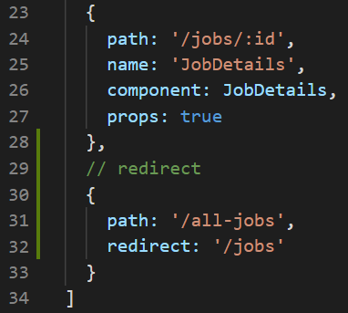

If the user types in the URL and ends the path with all-jobs then the user will be redirected to the jobs.

Type **localhost:8080/all-jobs** in the browser and press enter

**Output:**

BEFORE

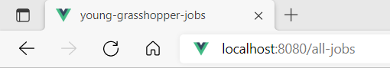

AFTER

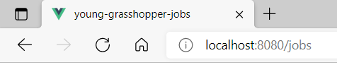

**Step 2:** If you type in a route that does not exist you will not see anything except for the navigation bar. Remember that the navigation bar is nested in the parent root, App.vue, so the navigation bar will always appear. This information is not useful to the user. So if a user types in a URL that does not exist then we want to direct them to a 404 or a not found page.

In the views folder, create a Vue component called NotFound.vue,

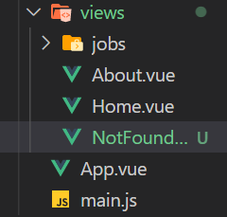

Setup the Vue component:

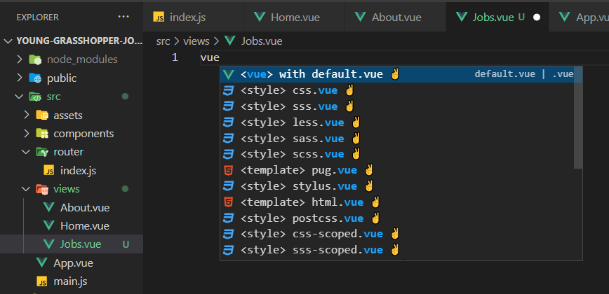

Inside the template, create an h2 tag with the text 404 and an h3 tag with the text Page Not Found. We will not be using the script tag so that can be removed.

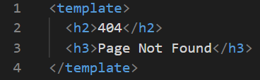

**Step 3:** In the router folder, in the index.js, we will be adding another route object inside the route array. We will include a callAll the path value, “/:catchAll(.*) , this will execute when a user types in a path that does not exist in the web application. “/:catchAll(.*) is a regex pattern built into Vue, it is not a function.

Look at the example below (**Between line 35 and 37**):

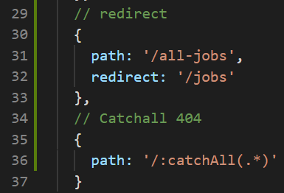

We can then redirect them to a different component. We can give the route a name which we can call NotFound. Then we can import the NotFound component and in the object the value for the component key will be not found.

Look at the example below (**Line 4**):

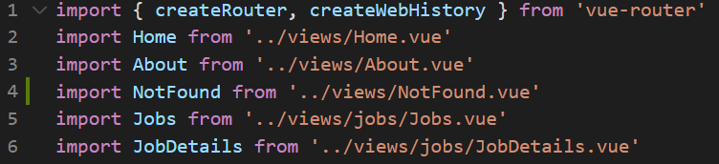

Look at the example below (**Between line 37 and 39**):

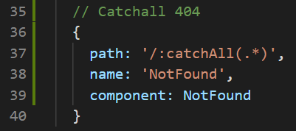

**Output:**

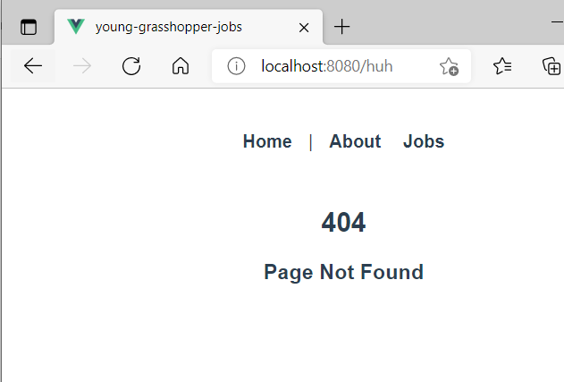

**You can view the code snippets from the** [**vue3-firebase-course**](https://github.com/younggrasshopperza/vue3-firebase-course) **repository under the Tutorial-40 branch**.